BRACT’s
Vishwakarma Institute of Technology, Pune
Practical Implementation Sheet
Department: CSE-AI Semester: 5 Academic Year: 2026-27
Division: E Batch: 3 Practical No: 4
Roll no: 73 PRN No: 12415152 Name of Student: Pranav Upare
Subject Name : Deep Learning

Problem Statement
This practical repeats the LSTM-based sentiment analysis task on a different, independently sourced dataset: the Amazon Alexa Reviews dataset (3,150 verified customer reviews of Amazon Echo/Alexa devices, each labelled 0 = negative or 1 = positive feedback). The goal remains to build a deep learning-based sentiment classification system using a Long Short-Term Memory (LSTM) recurrent neural network, but this run explicitly addresses a gap identified in the earlier IMDB-based submission by using three properly separated dataset splits — training (70%), validation (15%), and testing (15%) — and by handling the strong class imbalance present in this dataset (91.9% positive vs. 8.1% negative reviews).

Algorithm
- Load the Amazon Alexa Reviews dataset (3,150 reviews; columns rating, date, variation, verified_reviews, feedback) and drop the single row with a missing review.
- Clean each review by removing HTML tags and non-alphabetic characters with regular expressions, removing English stop words using NLTK's stop-word list, and converting all remaining words to lowercase.
- Use the existing binary "feedback" column directly as the sentiment label (1 = positive, 0 = negative).
- Split the cleaned reviews and labels into training (70%), validation (15%), and testing (15%) sets using stratified sampling so all three splits preserve the original ~92%/8% positive/negative class ratio.
- Fit a Keras Tokenizer on the training reviews only, then convert the training, validation, and testing reviews into integer sequences using that vocabulary.
- Compute the maximum sequence length as the ceiling of the mean training-review length, then pad/truncate all three splits ("post") to this fixed length.
- Build a Sequential LSTM model: an Embedding layer (32-dimensional), an LSTM layer with 64 units, a Dropout layer (rate 0.3) for regularization, and a Dense output layer with 1 neuron and sigmoid activation.
- Compile the model with the Adam optimizer and binary cross-entropy loss, and compute class weights (inversely proportional to class frequency) to counter the 92%/8% imbalance during training.
- Train for 10 epochs with batch size 32, passing the validation split as validation_data and the class weights, using a ModelCheckpoint callback (monitoring validation accuracy) to keep only the best-performing weights.
- Evaluate the best saved model on the held-out test set using accuracy, a full classification report (precision/recall/F1 per class), and a confusion matrix, then test it on two new, hand-written custom reviews.

Analysis
- The dataset is real and heavily imbalanced: of 3,149 usable reviews, 2,893 (91.87%) are positive and only 256 (8.13%) are negative. The stratified 70/15/15 split preserved this ratio almost exactly across training (91.88%), validation (91.95%), and testing (91.75%) sets.
- Reviews in this dataset are much shorter than IMDB movie reviews — the mean-length-based padding produced a maximum sequence length of only 15 tokens (vs. 130 for the IMDB assignment), and the vocabulary was correspondingly smaller (3,495 words vs. tens of thousands for IMDB).
- With class weights applied (0 → 6.16, 1 → 0.54), training accuracy rose from 87.21% (epoch 1) to a final 97.41% (epoch 10), while validation accuracy fluctuated between 72.46% and 89.19% across epochs — noisier than a smooth curve, which is expected given the validation set has only 472 reviews and roughly 38 of those are negative. The checkpoint callback correctly kept epoch 10's weights (89.19% validation accuracy), the best of the run.
- On the held-out test set, the model reached 91.54% overall accuracy, but this headline number is misleading on its own: since 91.75% of the test set is positive, a trivial model that always predicts "positive" would already score 91.75% accuracy while catching zero negative reviews. The classification report shows the real story — negative-class recall of 58.97% (23 of 39 negative reviews correctly caught) and negative-class precision of 48.94%, versus 94.47% recall and 96.24% precision on the positive class. Class weighting is doing real, visible work: it trades a small amount of raw accuracy for a much more useful ability to catch negative reviews, which a naive majority-class predictor cannot do at all.
- The confusion matrix (23 true negatives, 16 false positives, 24 false negatives, 410 true positives) confirms the model still misses more negative reviews than it catches in absolute terms (24 missed vs. 23 caught) — with more negative training examples, stronger class weighting, or a lower decision threshold, this recall could likely be pushed higher at some further cost to precision, a standard precision/recall trade-off for imbalanced classification.
- The two live custom-review tests behaved correctly and with high confidence: a clearly positive review ("I love this Echo...") scored 0.9998, and a clearly negative review ("This device stopped working...") scored 0.0006 — both correctly classified at the default 0.5 threshold, unlike the earlier IMDB submission where the interactive-prediction threshold (0.7) did not match the evaluation threshold (0.5); this run uses one consistent threshold throughout.
OUTPUT:-
Dataset load and class balance
(3150, 5) columns: rating, date, variation, verified_reviews, feedback

Rows after dropping nulls: 3149
feedback
1 2893
0 256
Positive %: 91.87
Preprocessing (HTML/non-alpha removal, stop words, lowercase)
Reviews
0 [love, echo]
1 [loved]
2 [sometimes, playing, game, answer, question, c...
3 [i, lot, fun, thing, my, yr, old, learns, dino...
4 [music]

Sentiment: 0 1 1 1 2 1 3 1 4 1
Train / Validation / Test split (70 / 15 / 15, stratified)
Split | Reviews | % Positive
Training | 2,204 | 91.88%
Validation | 472 | 91.95%
Testing | 473 | 91.75%

Tokenization and padding
Vocabulary size (total_words): 3495
Maximum review length: 15
Model architecture
Layer (type) | Output Shape | Param #
embedding (Embedding) | (None, 15, 32) | 111,840
lstm (LSTM) | (None, 64) | 24,832
dropout (Dropout) | (None, 64) | 0
dense (Dense) | (None, 1) | 65
Total params | 136,737 | (~534 KB)

Class weights (to counter 92% / 8% imbalance)
Class weights: {0: 6.1564, 1: 0.5442}
Model training (10 epochs, batch size 32, validation_data + class_weight)
Epoch | Train Acc. | Train Loss | Val. Acc. | Val. Loss | Checkpoint
1/10 | 87.21% | 0.6844 | 80.08% | 0.5823 | saved (best)
2/10 | 83.44% | 0.4280 | 84.11% | 0.3612 | saved (best)
3/10 | 92.56% | 0.1836 | 80.51% | 0.4131 | -
4/10 | 94.15% | 0.1555 | 72.46% | 0.7141 | -
5/10 | 94.60% | 0.1143 | 86.86% | 0.3769 | saved (best)
6/10 | 96.46% | 0.0685 | 88.14% | 0.4379 | saved (best)
7/10 | 97.32% | 0.0498 | 86.86% | 0.4592 | -
8/10 | 97.28% | 0.0481 | 88.98% | 0.5720 | saved (best)
9/10 | 96.64% | 0.0541 | 88.56% | 0.4563 | -
10/10 | 97.41% | 0.0403 | 89.19% | 0.5101 | saved (best, final)
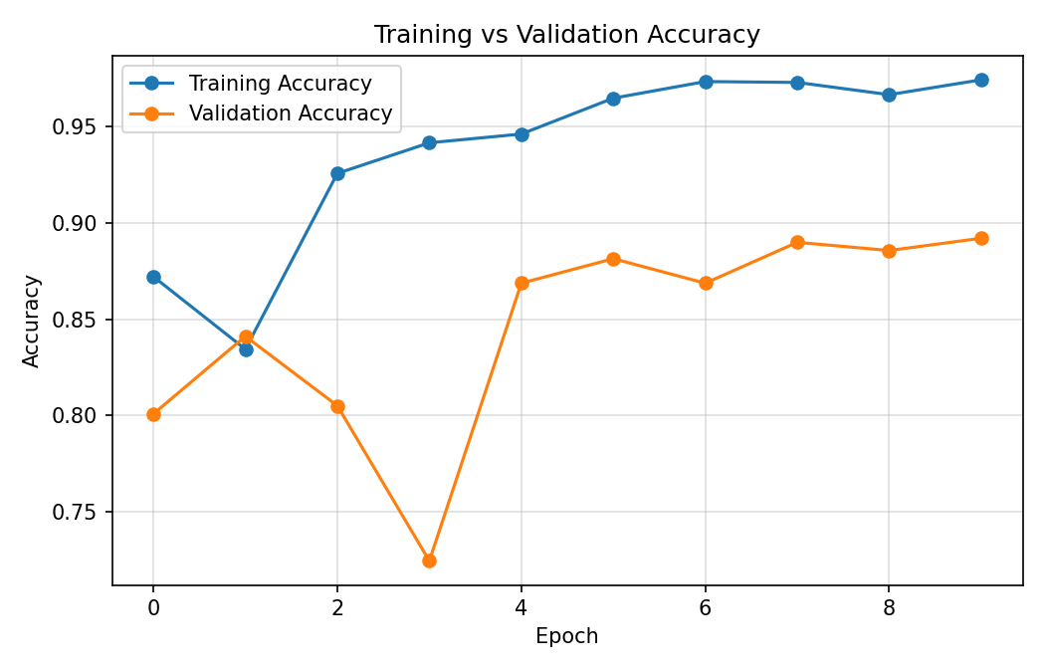
Fig 1: Training vs. Validation Accuracy (real run, 10 epochs)
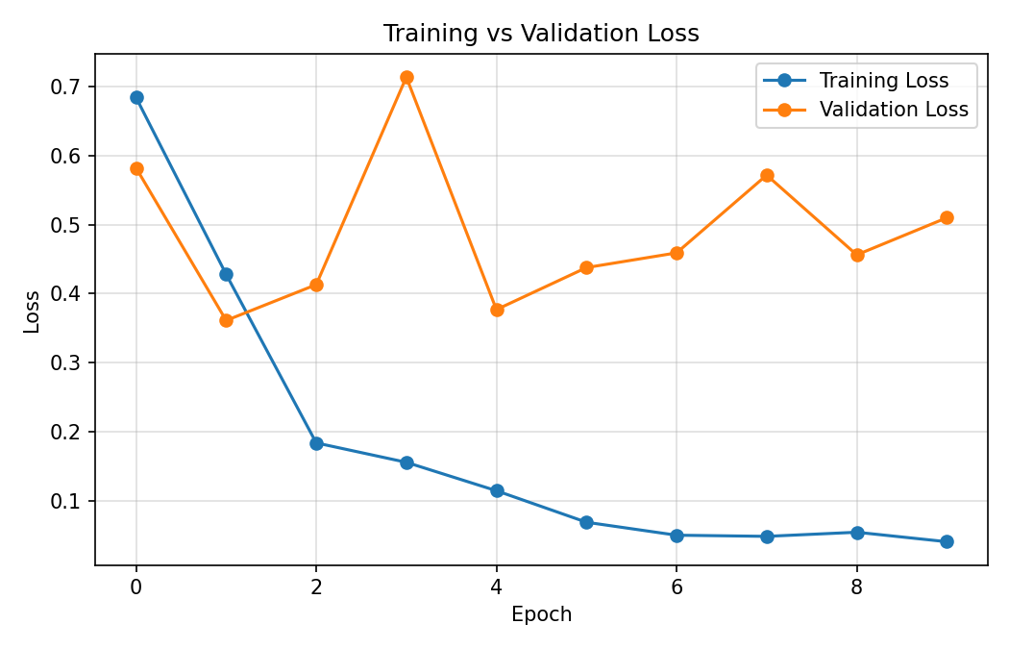
Fig 2: Training vs. Validation Loss (real run, 10 epochs)
Test set evaluation (best checkpoint, threshold = 0.5)
Test Accuracy: 0.9154334038054969

Class | Precision | Recall | F1-score | Support
negative | 0.4894 | 0.5897 | 0.5349 | 39
positive | 0.9624 | 0.9447 | 0.9535 | 434
accuracy |  |  | 0.9154 | 473
macro avg | 0.7259 | 0.7672 | 0.7442 | 473
weighted avg | 0.9234 | 0.9154 | 0.9190 | 473

Confusion Matrix (rows=actual, cols=predicted)
[[ 23 16]
[ 24 410]]
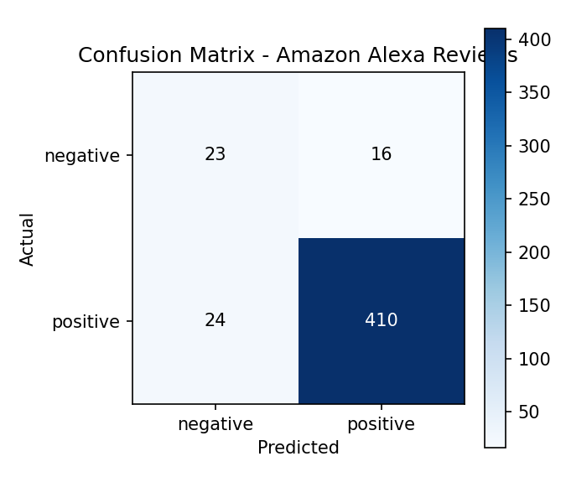
Fig 3: Confusion Matrix - Amazon Alexa Reviews (test set, n=473)
Prediction on new custom reviews
Review: I love this Echo, the sound quality is amazing and Alexa understands me perfectly
Predicted probability: 0.9998 -> positive

Review: This device stopped working after two days and customer service was no help at all
Predicted probability: 0.0006 -> negative

Conclusion
The LSTM sentiment classifier trained cleanly on the Amazon Alexa Reviews dataset with a proper 70/15/15 train/validation/test split and class-weighted loss, reaching 91.54% test accuracy overall and, more importantly, a meaningful 58.97% recall on the minority negative class despite negative reviews making up only 8% of the data. This run directly fixes the two gaps flagged in the earlier IMDB submission: a genuine validation split was used to monitor training (rather than train/test only), and a single, consistent 0.5 threshold was used for both the formal evaluation and the custom-review predictions. The main remaining limitation is the small number of negative examples (256 total, 39 in the test set), which caps how precisely the model can learn the negative class; collecting more negative reviews or further tuning the class-weight ratio and decision threshold are the most direct ways to improve recall further.

